HW 04 Due 03/05/14

Page 92: # 16, 22, 30
For question #30, reading Example 5, page 91, and example 4 from posted class notes, lesson 2.6, could help.

Note, I will be using the following set notation with the assumption that f(x) is defined in each question:

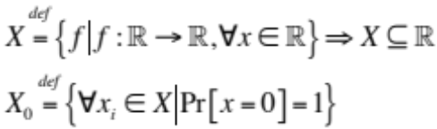

16.
Problem: Find the zeroes (if any) of the following function algebraically.
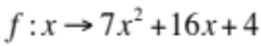
Solution:
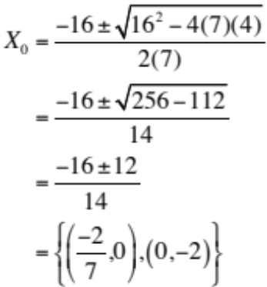

22.
Problem: Find the zeroes (if any) of the following function algebraically.
Solution:
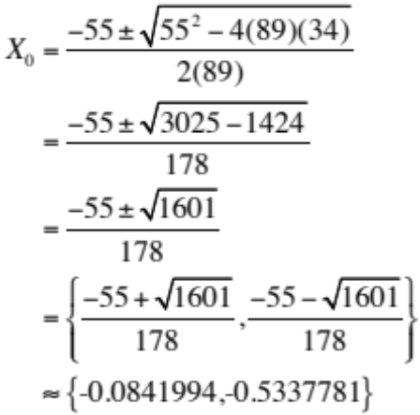
30.
Problem: A ball is thrown into the air. Its height (in feet) t seconds later is given by 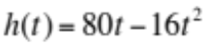.
- Evaluate and interpret 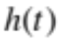
- Solve the equation 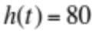. Interpret your solutions and illustrate them on a graph of .
Solution:
(a) 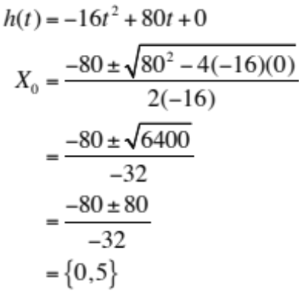
(b). 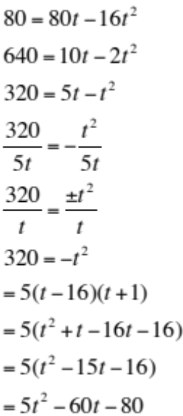

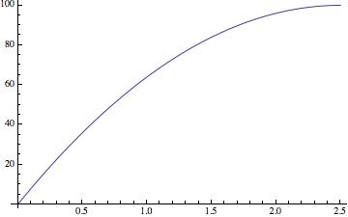

Page 112: # 16, 26.

Problem 16:
(i) 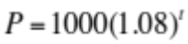
(ii) 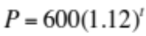
(iii) 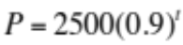
(iv) 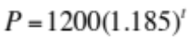
(v) 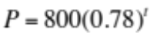
(vi) 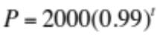

Towns that are growing: {i, ii, iv}
Towns decaying: {iii, v, vi}.
Fastest growth: iv, 18.5%
Fastest decay: v, 22%
Largest initial population: iii, 2500
Smallest initial population: 600

Problem 26:
- 25
- 15%
- 4.92186010851807

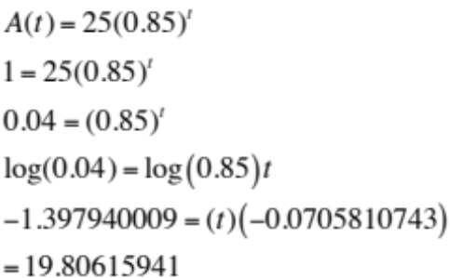

Page 120: # 22, 34, 36.

Problem 22:
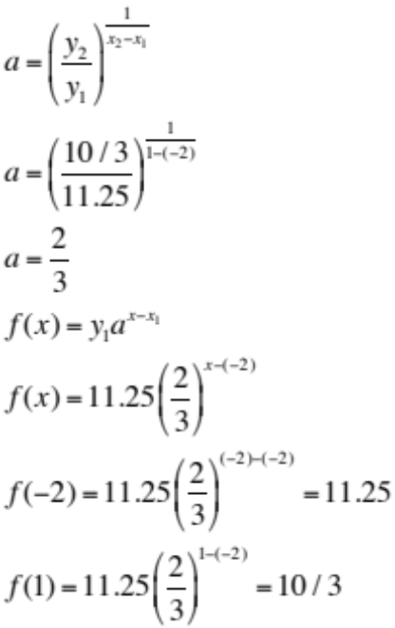

Problem 34:

a) 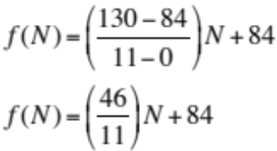

b)
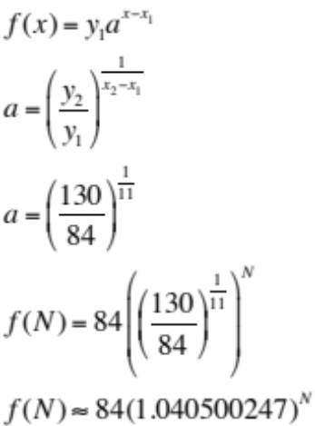

c)
Linear: 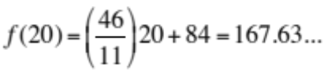

Exponential:
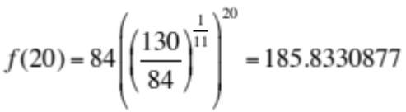

Problem 36:

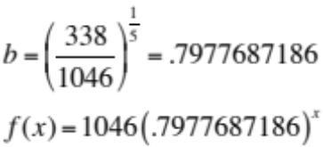

Page 127: # 4, 18, 40
For question #40, read example 3, posted class notes lesson 3.3;
Also, in #40, be aware that t is the number of years since 1994.

Problem 4:

f(x) is decreasing the fastest
h(x) is decreasing the slowest
g(x) is in the middle.

Problem 18:

a)
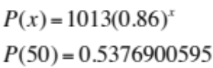

b)

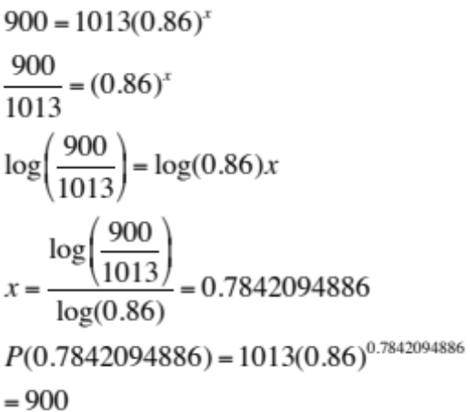

Problem 40
a) 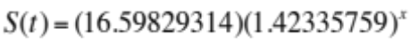
b) The function S(t) seems to fit the data well, however there may be some floating point imprecisions.
c) 42.335759%
d) The sales in the year 2010 should be approximately 4710.725252 million.

